PROJECT TITLE

Electric motor temperature prediction using machine learning
Artificial Intelligence & Machine Learning

TEAM ID: LTVIP2026TMIDS42348

TEAM MEMBERS(ROLES):

- Shaik Rizwana– (Team Leader)

- R Rajagopal (Team Member)

- Samuel Morries (Team Member)

- Pattikonda Shaik Shafi (Team Member)

Table of Contents
- Introduction
- Project Overview
- Architecture
- Visualizing and analyzing the data
- Setup instructions
- Folder structure
- Running the Application
- API Documentation
- User Interface (Screenshot Section)
10 .Testing
11.Demo Video
12.Known Issues
13.Future Enhancements

Introduction

Electric motors are widely used in industries, electric vehicles, manufacturing units, and household appliances. One of the major reasons for motor failure is overheating. High temperature affects insulation, reduces efficiency, and eventually damages the motor permanently.Traditional monitoring systems only alert after overheating happens. This project proposes a predictive system that estimates the motor temperature in advance using Machine Learning. By predicting temperature early, industries can perform preventive maintenance and avoid costly breakdowns.
The goal of this project is to develop a Machine Learning model that can predict the motor temperature based on sensor data such as:
Voltage
Current
Speed
Torque
Ambient temperature
The system helps operators monitor motor health and increases reliability and safety.

Project Overview

This project uses a supervised machine learning algorithm to predict the temperature of an electric motor in real-time.

Key Objectives:

Predict motor temperature before overheating occurs
Reduce equipment failure
Enable preventive maintenance
Improve motor life and efficiency

Technologies Used:

Python

Machine Learning (Regression Algorithms)

Scikit-learn

Pandas & NumPy

Flask (for web application/API)

Matplotlib (for visualization)

Workflow:

1. Collect sensor data

2. Preprocess dataset

3. Train ML model

4. Predict temperature

5. Display results on web interface domain.

3. Architecture

The system consists of four main components:

1. Data Input Layer
receives motor sensor parameters like Voltage, current, speed, torque, ambient temperature
2. Processing Layer
Data cleaning
Normalization
Feature selection
3. Machine Learning Model
Trained regression model (Random Forest / Linear Regression)
Predicts motor temperature
4. User Interface
User enters motor parameters
System displays predicted temperature
Flow:
Sensor Data → Preprocessing → ML Model → Temperature Prediction → User Display
.
- PROJECT STRUCTURE
- Rotor Temperature Detection.ipynb is the jupyter notebook file where the model is built.
- Dataset.zip is the dataset file used in this project.
- model.save is the model file that generates when the notebook file is executed.
- transform.save is the transformation file used while building the model.
- Flask folder is the application folder where the web application and server-side program are present.
- IBM scoring endpoint is the folder that contains IBM training code and flask files related to IBM

Visualizing and analyzing the data
As the dataset is downloaded. Let us read and understand the data properly with the help of some visualization techniques and some analyzing techniques.
Note: There is n number of techniques for understanding the data. But here we have used some of it. In an additional way, you can use multiple techniques.

Setup Instructions
These steps to run the project on computer.

Step 1: Install Python

Download and install Python (version 3.8 or above).

Step 2: Install Required Libraries

Open terminal/command prompt and run:

pip install numpy
pip install pandas
pip install matplotlib
pip install scikit-learn
pip install flask

Step 3: Download Project Files

Extract the project folder.

Installation:

Clone the repository:

Navigate into the project directory:

cd electric temperature PredictionApp-

Install Python dependencies:

pip install Flask tensorflow opencv-python Pillow numpy (or list specific versions if needed in a requirements.txt file)

Download the dataset and pre-trained model:
The dataset (if needed for re-training or local setup) should be downloaded separately (e.g., from Kaggle, as mentioned in my demo video).

Folder Structure

dataset → contains training data

model → saved machine learning model

templates → web pages

static → CSS files

app.py → main application

train_model.py → model training script

templates/: Contains HTML files that define the user interface (e.g., index.html).

static/: (Expected if present) Would contain static assets like css/ for stylesheets, js/ for client-side JavaScript, and uploads/ for temporary uploaded images.

Server (Backend):

app.py: The main Flask application file, handling routes, model loading, image processing, and predictions.
train_model.py: Script for training and evaluating the machine learning model.

data_prep_and_viz.py: Script for data preprocessing and visualization.

Running the Application

Open terminal

Navigate to project folder

cd Electric-Motor-Temperature-Prediction

3. Train the model

python train_model.py

4. Run the web application

python app.py

5. Open browser and go to:

http://127.0.0.1:5000/

Now the prediction system will appear.

Local Setup (e.g., in a terminal after cloning):

- Ensure all prerequisites are met and dependencies are installed.
- Start the Flask backend: python app.py

- The application will typically run on http://127.0.0.1:5000.

Google Colab Setup (as shown in the demo video i.e., GITHUB repositary):

- Mount Google Drive.
- Unzip your project into /content/Electric motor temperature prediction Project.
- Change the current working directory to /content/Electric motor temperature prediction Project.
- Install required libraries within the Colab notebook.
- Run app.py in the background (e.g., !nohup python app.py > app.log 2>&1 &).
- Start ngrok to expose the Flask port (e.g., !ngrok http 5000). Access the application via the provided ngrok public URL.

API Documentation

The application provides a web interface rather than a public API for direct consumption.
However, the backend exposes the following key routes handled by

app.py:

/ (GET): Serves the main index.html page, which is the entry point for the application.

/predict (POST): Accepts an image file (typically via a form submission).

9.User Interface (Screenshots Section)
The UI is a simple web page allowing users to upload an image file. After processing, it displays the prediction result clearly.
THE WEB PAGE ALLOWING USERS TO UPLOAD AN IMAGE FILE:

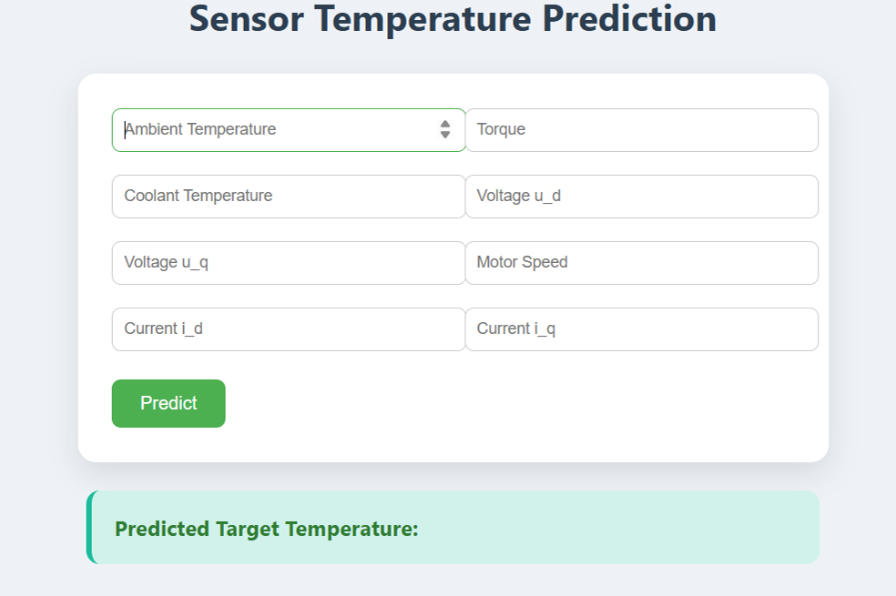
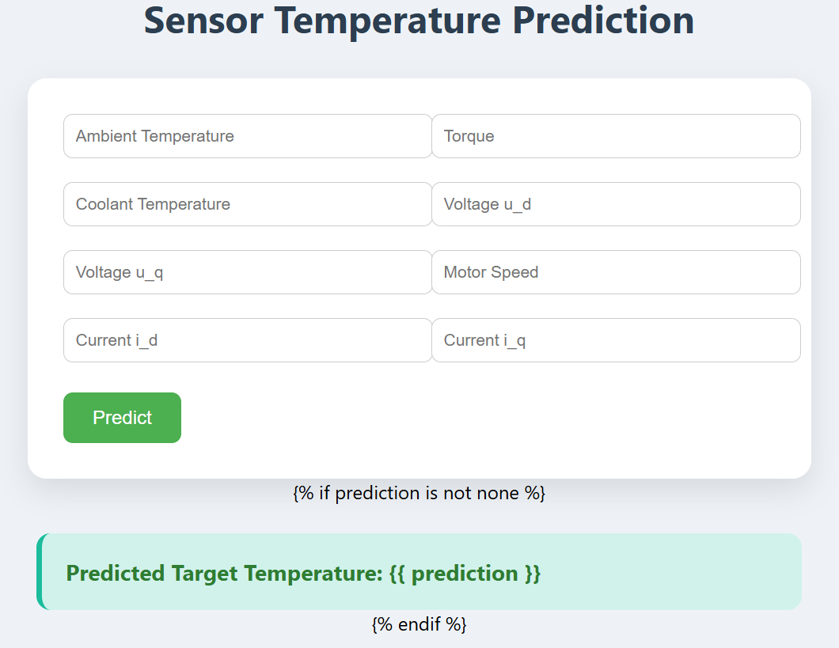

PREDICTION RESULTS:

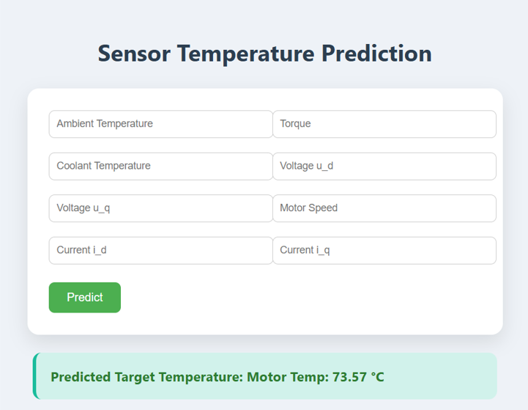
LINK Strategy: Testing primarily involves verifying the accuracy of the machine learning model (during training in train_model.py) and ensuring the web application correctly handles image uploads and displays predictions.
Tools: Standard Python unit testing (e.g., unittest or pytest) could be used for backend logic, and manual testing for the web interface.

11.DEMO VIDEO :

12. KNOWN ISSUES:
Model Generalization: The model's performance might vary with images of fruits/vegetables not well-represented in the training dataset or under different lighting/background conditions.
Scalability: The current setup is for demonstration; scaling to handle many concurrent users would require more robust deployment (e.g., using Gunicorn/Nginx) and potentially cloud resources.

13 .FUTURE ENHANCEMENTS:
  - Expand Dataset and Model: Train on a larger, more diverse dataset to recognize more types of fruits/vegetables and a wider range of diseases/spoilage.
  - User Accounts: Implement user authentication to manage user-specific data or features.
  - Prediction History: Add a database to store user upload history and prediction results.
  - Mobile Responsiveness: Improve the frontend design for better display on mobile devices.
  - Real-time Feedback: Provide more detailed feedback to the user on image processing or model inference time.
  - Deployment Automation: Automate deployment to a cloud platform (e.g., Google Cloud Run, AWS Elastic Beanstalk

